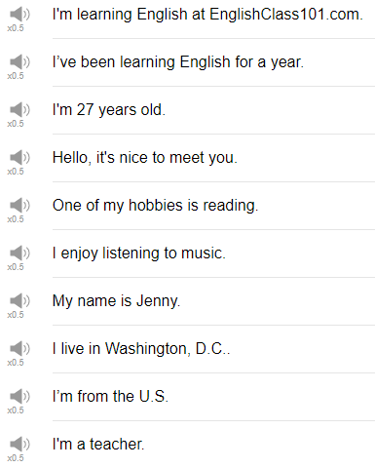

|  |
| --- |
| Hi everybody! My name is Alisha, and welcome back to Top Words. Today's topic is 10 lines you need for introducing yourself. So let's go! |
| Hello. It's nice to meet you. |
| Hello. It's nice to meet you. You can only use this the first time that you meet someone if you say this to somebody after you have met them already, you're going to seem either A) like you've completely forgotten meeting them or B) like you are a very strange person for saying it's nice to meet you again. So when you use this the first time you can shake hands with someone and say Hello. It's nice to meet you. |
| My name is... |
| The next phrase is my name is blah blah blah. my case my name is Alisha. You can use this again when you're introducing yourself, or if you need to re-introduce yourself, you can use this pattern when you meet somebody at a party, for example, you can say my name is... My name is Barbara. My name is Stevens. You can shorten this you can say my name's. My name's blah blah blah. |
| I'm from... |
| after you said your name after you shaking hands you can say, I'm from US. I'm from Japan. I'm from Turkey. I'm from your mom's house. I'm from a cave in southern Europe. I'm from your country, or I'm from your city. I'm from the future! |
| I live in... |
| I live in blah, blah, blah. You can use your city, you can use your country, you can use even maybe if you live near a certain station you can use the name of the station, where you live. So for example, I live in America, it's fine. I live in Los Angeles, is fine. I live in New York, is fine. So your neighborhood is fine. If someone says where do you live and you say I live in an apartment... What? So please use your, the region or the location where you live, not the type of place where you live. |
| I'm a... |
| if you hear the question "what do you do?" It's asking about your job. In English people don't say "what is your job", that's not the question that we asked. Instead the question is "what do you do" and the correct response to that is I'm a... or I'm an... blah blah blah, followed by your job title. So if someone says what do you do? you can say, I'm a teacher. What do you do? I'm an engineer. What do you do? I'm a donut - shop - tester. |
| I'm ... years old. |
| When someone asks "how old are you?" You can say I'm blah blah blah years old. Don't forget the S at the end of this. If you like, you can shorten this phrase to just "I'm (plus your age)." So I'm 65. I'm 13. Whatever. I'm this many. Sometimes children will say that "how old are you?" I'm this many! Kind of cute. First time you meet someone who might not ask how old are you. If it's in a friendly case and a party after you've spoken to the person a little bit, it's ok, but just trying to be sensitive to the context, try to be sensitive to the people around you. And if you sense that maybe there's a very large age gap between you, might be better not to ask the question at all. |
| I enjoy... |
| Many of my students say "what is your hobby?" but that's not something that native speakers will say. No native speaker say what is your hobby? Instead, we ask what do you like to do? or "what do you do in your free time?" It's a much more natural question then "what's your hobby". The answer to this then is I enjoy or I like plus a noun phrase. so for example "what do you like to do?" I like listening to music, or I enjoy listening to music. "What do you do in your free time?" I like watching movies. "what do you do in your free time?" I like baking cakes. "What do you do in your free time?" I enjoy tap dancing. What do you do in your free time? I enjoy making new friends. |
| One of my hobbies is... |
| One of my hobbies is blah, blah, blah. With this one, it's probably better to use a short, easily, easy-to-understand hobby. If you're explaining a hobby people are going to expect that it's going to be something that they know about, like photography, or cooking, or dancing, or swimming, or whatever. So try to pick something that will allow you to continue the conversation. That's why movies, or cooking or books, or, you know, sports, are good thing to share. One of my hobbies is snowboarding. |
| I've been learning English for... |
| If you are learning English, if you're studying English, you can use this expression. If someone asks you "how long have you been studying English?" you can say, I've been studying English for amount of time, or I've been learning english, or I've been practicing English, or I've been speaking English for a certain amount of time. I've been studying English since elementary school is also OK to use. I've been studying English since I was in college just be careful "for" is used for a length of time, and "since" is used for a specific point in time at which you started something. So you can try and mix it up and use a few different expressions there. So, I've been learning English for a long time, I'm still learning English, you shouldn't do that too. Ok! I'm learning English at EnglishClass101.com This probably could be used in response to "where did you learn English?" or "where are you studying English?" or "how are you studying English?" You can respond with I'm learningEnglish at EnglishClass101.com, or I'm learning English at my school, I'm learning English at my private teachers house, for example. |
| So a little bit of grammar in this sentence, why do we use the progressive tense I'm learning English? If you say "I'm learning" it sounds like you're still continuing your studies; if you say "I learned English" at EnglishClass101.com it sounds like you're finished. I like you you're finished studying, there's nothing else for you to study, so you're done. So it's much much more natural to actually use the progressive "I'm learning" or "I'm studying" when you're talking about your studies when you're talking about your hobbies, that is to say I learned or I studied and and and and. |
| So those are 10 lines that you need to introduce yourself and they help give the other person a little bit of information and carry the conversation forward. So please try them, go crazy with them, make them your own. Thanks very much for joining us for this episode of Top Words We'll see you again soon. Bye! |
| I'm from your neighbor's dog house-ish. |
| Glub glub. Oh yes I like to go spelunking in North Africa every summer. |